**TREMEC T-5 5-Speed**

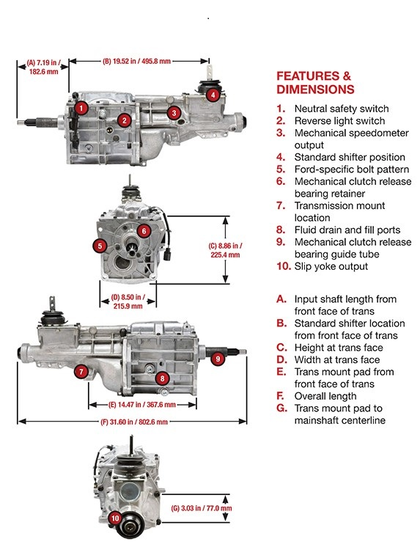

The TREMEC T-5 was the first modern 5-speed manual transmission used by Ford and GM in vehicles like the Fox Body Mustang and Chevrolet Camaro/Pontiac Firebird. It’s features include:

* Compact size ideal for vintage cars and trucks with small transmission tunnels
* Smooth and easy, low-effort shifting
* 300 lb-ft torque capacity
* Kits and support parts available from TREMEC Elite Distributors to aid with installation

**TREMEC TKX 5-Speed**

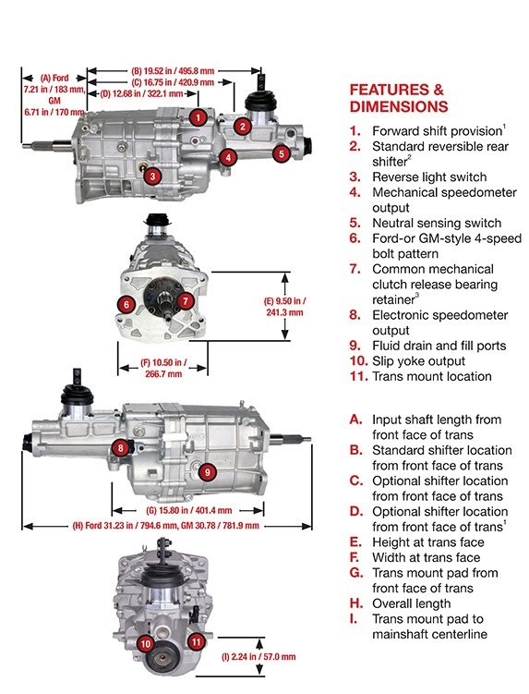

The TREMEC TKX 5-speed was designed for easy retrofits into classic muscle cars and trucks. It has a classic 4-speed bolt pattern and a slender, high-strength aluminum case designed to fit many stock muscle car transmission tunnels without requiring modification to the tunnel.

* High-RPM (up to 7,500) smooth shifting
* More than 600 lb-ft torque capacity
* Designed for multiple applications with three shifter locations
* Superior shift-ability through use of multi-cone synchronizers and hybrid synchronizer rings made of sintered bronze and carbon
* Robust design with internal three-rail shift system and a combination of aluminum and steel shift forks
* Optional gear ratios make the TKX capable of handling a wide array of performance requirements

**TREMEC TR-4050 5-Speed**

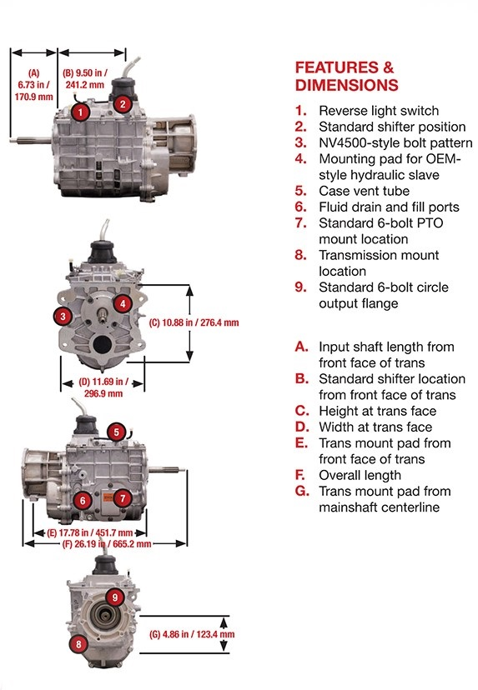

The TREMEC TR-4050 5-speed is based on a production transmission used in a variety of OE 4×2 and 4×4 applications. It is a great choice for a variety of light-truck and SUV swaps along with regular truck duties like towing, off-roading/rock-crawling. Its features include:

* Ideal replacement for NV4500 manual transmissions with lighter overall weight, updates and improvements
* All five forward gears and Reverse are fully synchronized
* Countershaft-mounted Fifth gear synchronizer reduces NVH (Noise, Vibration and Harshness) when Overdrive gear is engaged
* Super low 6.16:1 “granny” First gear is ideal for off-roading and trucks hauling heavy loads
* The 0.76:1 Fifth gear overdrive allows for more efficient highway speed capability with lower engine RPM
* Six-bolt PTO mounting allows for attachment of most common PTO-driven accessories

**TREMEC Magnum 6-Speed**

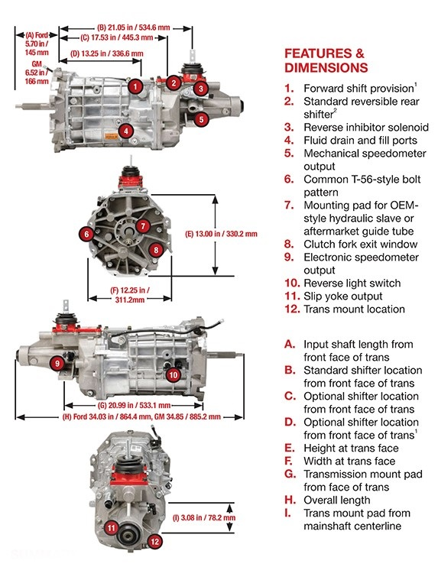

The TREMEC Magnum 6-speed is based on the popular OE TR-6060 6-speed found in several modern high-performance vehicles. It has been a favorite among modern muscle car builds, drag racing, road racing and auto-cross vehicles for more than a decade.Its features include:

* The T-56 style bolt pattern makes installation with various late-model engines easy
* Double-overdrive design gives the Magnum 6-speed capability for a wide array of performance applications including high-horsepower/torque street-strip vehicles
* Torque capacity rating of 700 lb-ft
* 7,800 RPM shift capability
* Optional gear ratio sets make allows you to choose a Magnum 6-speed most suited to your specific vehicle use

**TREMEC Magnum-F 6-Speed**

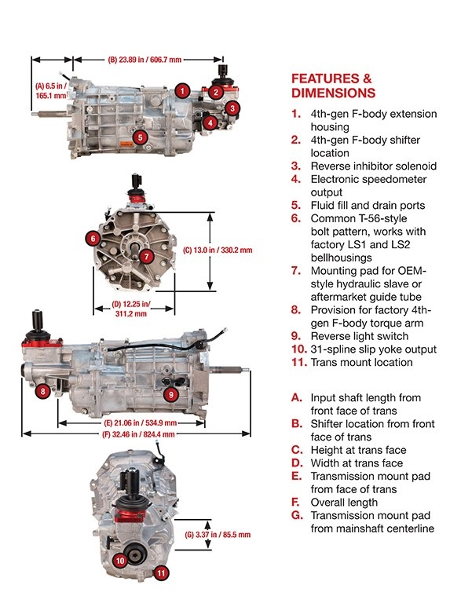

The TREMEC Magnum-F 6-speed was designed specifically as an upgrade replacement for factory-equipped T-56 4th-generation Chevrolet Camaros and Pontiac Firebirds/Trans Ams. Its featured include:

* Straight-forward swap for 1998-2002 LS1-powered Camaros and Firebirds/Trans Ams, fitting the transmission tunnel and locating the shifter in the stock location
* It can be swapped into 1993-1997 LT1-powered Camaros and Firebirds/Trans Ams with minimal extras needed
* Provisions for third- and fourth-generation F-body factory torque arm mount cast into tailshaft housing
* Ideal for other applications where T-56s were desired for their shifter location
* Eliminates the need to hunt for used T-56s or paying for costly rebuilds
* Gives 4th-generation F-body owners the perfect transmission upgrade that supports modern performance power levels
* For 3rd-generation F-body owners, it allows for installation of the high-performance manual transmission third-gen owners wished their cars had from the factory
* Also ideal for LS-swapped late-models of all varieties including A80 Supras and FD RX-7s

**TREMEC Magnum XL 6-Speed**

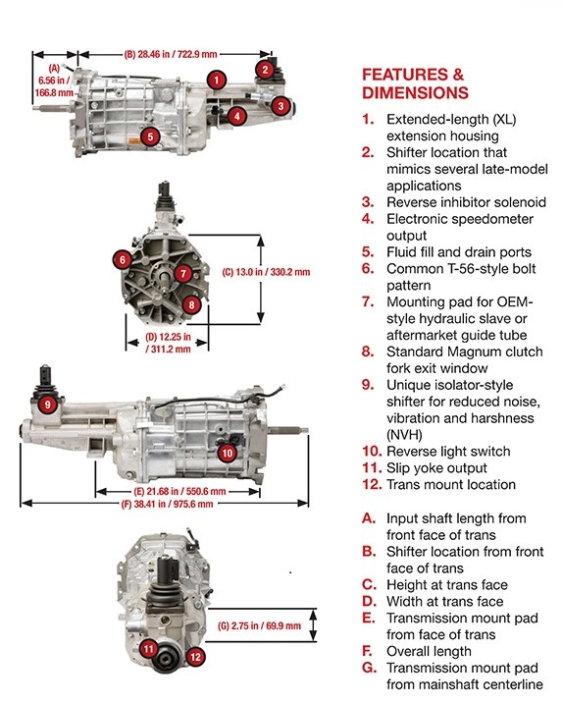

The TREMEC Magnum XL 6-speed is an extended-length version of the standard Magnum 6-speed. It is ideal for late-model applications that use performance-challenged semi-remote shifters. Featured include:

* Ideal shifter location without problematic semi-remote shifter mechanism
* Provides a shifter location further back in the vehicle for classic car and truck builds that desire this
* Available in kit form for 2005-up Ford Mustangs and 2010-2015 Chevrolet Camaros that include SFI bellhousing, shifter handle and crossmember